Comparing future patterns of energy system change in 2°C scenarios to expert projections

Mariësse A.E. van Sluisveld ^{a b}, Mathijs J.H.M. Harmsen ^{a b}, Detlef P. van Vuuren ^{a b}, Valentina Bosetti ^{c d}, Charlie Wilson ^{e}, Bob van der Zwaan ^{f g h}

ª Copernicus Institute of Sustainable Development, Utrecht University, Utrecht, The Netherlands
^{b} Netherlands Environmental Assessment Agency (PBL), the Hague, The Netherlands
^{c} Economic Department, Bocconi University, Milan, Italy
^{d} Fondazione Eni Enrico Mattei (FEEM), Milan, Italy
^{e} Tyndall Centre for Climate Change Research, University of East Anglia, Norwich, UK
^{r} Policy Studies, Energy research Centre of the Netherlands (ECN), Amsterdam, The Netherlands
^{g} Faculty of Science (HIMS), University of Amsterdam, Amsterdam, The Netherlands
^{h} School of Advanced International Studies (SAIS), Johns Hopkins University, Bologna, Italy

Abstract
Integrated assessment models (IAMs) are used to assess the implications of human activity on our planet’s climate and to explore possible response strategies to unwarranted anthropogenic climate change. While the results of these models have been found to be useful for decision-making processes, there has also been critique on the necessary simplifications of emulated real-world processes. Examples of simplified processes in these models are the aggregated representation of techno-economic decision-making, the use of cost-optimal allocation of investments and their focus on impacts over long time horizons. The aim of this paper has been to identify whether IAM projections diverge in systematic ways from expert projections as a result of their configuration. We carried out an expert elicitation on technology deployment for business-as-usual and stringent climate policy scenarios until 2030 and 2050. We compared the outcomes of the expert elicitation to IAM projections on solar, wind, biomass, nuclear and CCS technology depictions to search for systematic differences as well as commonalities for projected energy system change. Overall agreement between IAMs and experts was found on system developments along current trajectories. Residual differences in depicted scales and speeds of change were attributable to the narrower set of system components and incentives considered in IAMs than by experts. Divergence both within and between IAMs and experts was found under assumptions of stringent climate policy. IAM results were found to be biased towards large scale technologies and show to be constrained by existing infrastructures. Experts are more optimistic about technologies that are particularly suitable for distributed and decentralized applications, like solar and wind power. Even though some overlap can be observed between IAM and expert projections, hinting to agreement, experts have expressed restraint for some depicted values, in particular for the projections related to biomass in power production as well as nuclear and CCS. Although this can be partly attributed to different expectations in the availability and economics of mitigation technologies, it also underlines that more complex dynamics need to be taken into consideration than currently accounted for in IAMs to represent plausible future pathways of technology deployment. The results therefore provide indication on achievable and likely energy system change which the IAM community could take into further consideration.

Keywords: Technology diffusion, integrated assessment, climate change, 2 degrees, expert elicitation

Introduction
Integrated assessment models (IAMs) are used to assess the implications of human activity on the Earth atmosphere’s climate and to explore possible response strategies to global warming. Scenarios generated by these models provide guidance on the timing of emission reduction, the required change in the technological infrastructure, and the potential contribution of different world regions (e.g. Calvin et al. (2012); Kriegler et al. (2013); Riahi et al. (2015); Tavoni et al. (2015); Weyant and Kriegler (2014)). Model-based scenarios play an important role in informing society about the effects of future policies. For instance, the assessment of the IPCC regarding mitigation strategies relies heavily on a database of about 1200 model-based scenarios (Clarke et al., 2014). Similarly, the European Commission devises model-based scenario studies to anticipate on emerging trends and consider long-term approaches to investments (European Commission, 2011; European Union, 2012). Although the scenario literature is aware of the shortcomings, there is increasingly more interest in the validation of (1) the integrated assessment instruments and (2) their depictions of achievable technological growth under stringent climate mitigation considerations (Anderson, 2015; Stern, 2016).

The literature focused on validating the ability of IAMs (and related models) to capture future (energy) system change have emphasized the difficulty of using formal validation methods. The main reason is that IAMs are designed to capture long-run dynamics of aggregated human (techno-economic) activity and are not intended to represent short-term socio-economic or socio-political volatility or in-depth detail of socio-technical systems which are acknowledged to strongly influence near-term observations of system behaviour (van Vuuren et al., 2010). Still, several methods have been proposed and used to validate IAM model behaviour including, among others, model comparison (Kriegler et al., 2015a; Riahi et al., 2015; Tavoni et al., 2015), comparative analysis of historical rates of change (Kramer and Haigh, 2009; Metayer et al., 2015; Van Der Zwaan et al., 2013; van Sluisveld et al., 2015; Wilson et al., 2012), behaviour validity (Schwanitz, 2013) and the development of diagnostic indicators and model classifications (Kriegler et al., 2015a). While such studies provide insight into the model performance, as well as useful reference points for technological challenges in transition scenarios, they are not conclusive on real world representations.

Several strands of literature have sought alternative methods to look at plausible future evolutions of various system components. One of those alternative methods is systematically consulting experts, whom are assumed to have a holistic view of the challenges for particular technologies, via a structured elicitation protocol. For example, various expert elicitations have focussed on the change of costs for electricity under various descriptive scenarios on RD&D funding (see, for example, the elicitations on biomass energy (Fiorese et al., 2014), solar PV (Bosetti et al., 2012; Curtright et al., 2008), nuclear energy (Anadón et al., 2012; Baker et al., 2008) and CCS (Baker et al., 2009; Chan et al., 2011; Nemet et al., 2013; Rao et al., 2006) technologies), which could either contrast or inform IAMs on likely short-term developments. Although such consultations provide useful references for possible future potential, expert judgements are known to be susceptible to cognitive biases (Marquard and Robinson, 2008) and usually do not stretch over very long temporal scales. In that light, expert elicitations do not disclose clearly what future state is depicted nor whether it is aligned to long-term climate objectives.

As a response to the debate on possible bias in IAM literature and the issue of IAM validation, we present a novel approach for testing IAMs on representing plausible futures. In this study we compare IAM model projections to expert projections to identify whether IAM projections diverge in systematic ways from expert opinion. To our best knowledge, expert elicitations have rarely focused on actual deployment levels of technologies and have not found an application yet in a direct comparison to IAM outcomes. Only a few expert elicitation studies have looked previously into the diffusion of energy technologies, predominantly focusing on driving forces and evaluation criteria and applying ranking to importance methods (see e.g. (Napp et al., 2015; Vaughan and Gough, 2016)), though, this type of research remains on a qualitative level and therefore cannot be compared on face value to IAM output. This study thus mobilises the strengths of both assessment methods on future system change to yield new insights on mapping and gauging uncertainties in the future evolutions of technological change. The following research questions are addressed: Do expert judgements deviate from model projections on future rates of technological change in the near (2030) to medium (2050) future? And what are the defining elements causing deviations between IAM and expert projections?

As the decarbonisation of the power sector can be considered the most prominent response strategy to meeting long-term climate targets in IAMs, we focus on key electricity supply technologies that contribute to decarbonisation in IAMs (solar PV, wind, nuclear, biomass and thermal plants combined with CCS). Each key electricity supply technology represents the collective power production of all related technologies (e.g. not specifying to onshore or offshore).

Methodology
In this study we carried out an comparative analysis where we draw from insights of IAM models as well as experts projections on the feasibility of technology diffusion in the near (2030) to medium-term (2050) future. In this section we will elaborate on the considered method for both analytical approaches.

Models and scenarios

Set of Integrated Assessment Models
Table 1 presents the five Integrated Assessment Models (IAMs), the results of which have been combined for the present analysis: REMIND (Bauer et al., 2013; Luderer et al., 2013); MESSAGE (Messner and Strubegger, 1995); IMAGE (Stehfest et al., 2014); WITCH (Bosetti et al., 2006) and TIAM-ECN (Keppo and Zwaan, 2011)). The survey does not focus on the individual results of these models, but shows the range of model outcomes that have been produced in a harmonized modelling protocol (see for example Kriegler et al. (2015b); Kriegler et al. (2013); Kriegler et al. (2014)). We utilize the multi-model inter-comparison set-up as a means to ensure that key structural uncertainties are taken into account through the diversity of participating models and model assumptions (Tavoni et al., 2015).

The five models represent a diverse array of different solution frameworks (general equilibrium, partial equilibrium, dynamic recursive, perfect foresight and systems engineering) and differ in a variety of model characteristics, such as their spatial, sectoral and technological resolution as well as in their assumptions that drive technology diffusion. However, one commonality in these models is that they predominantly utilize the same policy instrument to influence the system in attaining a specified climate target; the carbon tax. The carbon tax increases the relative price of energy carriers with a carbon content, creating a price-based preference order that favours carbon-free or carbon-removal over fossil-based technologies.

Table 1 - key model characteristics, adapted from (Kriegler et al., 2015a)
Name | Time horizon | Model category | Intertemporal Solution Methodology | Tech diversity in low carbon supply | Classification^{*1}
IMAGE | 2100 | Partial equilibrium | Recursive dynamic | High | High response
MESSAGE | 2100 | Partial equilibrium | Intertemporal optimization | High | High response
REMIND | 2100 | General equilibrium | Intertemporal optimization | High | High response
TIAM-ECN | 2100 | Partial equilibrium | Intertemporal optimization | High | High response^{*2}
WITCH | 2100 | General equilibrium | Intertemporal optimization | Low | Low response
*¹ Classification represents a pattern of common model behaviour in response to a carbon tax in terms of cumulated carbon reduction, carbon over energy intensity reduction and structural changes in energy use (primary energy).(Kriegler et al., 2015a)
*² assumed classification

Scenarios
The scenarios that are taken into consideration are two stylized pathways that represent a scenario without climate policy and a policy scenario limiting temperature increase to no more than 2°C by 2100 under idealized circumstances. These scenarios have been developed as part of the LIMITS project which examined the implications of various stringencies in climate policies and timing on meeting the 2˚C target in 2100 (Kriegler et al., 2013).

- The baseline (Baseline) scenario addresses the business-as-usual scenario in which there will be no new global agreement on international climate policy. Changes in the energy system will therefore mostly be driven by other factors than climate policy.

- The second (2 Degrees) scenario is a cost-optimal mitigation scenario that will restrict the global increase in temperature to a maximum of 2 degrees Celsius in the year 2100. The cost-optimal scenario assumes immediate and universal implementation of a global carbon tax. As such, the scenarios do not explicitly account for important social, political and institutional dimensions to real-world feasibility. Projected rates of change can thus be considered ambitious, and equivalent to a techno-economic potential.

Expert elicitation

Expert selection
To gain alternative insights about uncertain futures we have selected experts with a comprehensive view of all the various factors that may stimulate or inhibit the development of a specific technology (both technical aspects, as well as energy system dynamics in its entirety). The starting point for finding relevant participants in this elicitation has been extracting names of the lead-authorships of technology focussed chapters of key assessment and synthesis products such as IPCC AR4 (Sims et al., 2007), GEA (GEA, 2012), SRRES (Edenhofer et al., 2011) and REN21 (REN21, 2014). We thus draw from earlier selection procedures that warrant their expertise. Each expert was contacted via email and invited to take part in the survey after having received an explanation of the project aim. In the case of lack of response the participating experts were requested to propose an alternative participant following a snowball sampling technique. This network approach has been particularly important to approach bioenergy and nuclear experts in this study.

A total of 39 experts took part in our analysis (33% of the 117 experts contacted), including representatives of universities or research institutes (51%), member-based organizations dedicated to a specific technology (21%), governmental agencies (15%), private sector (8%) and intergovernmental organizations (5%) (see Table 2, and the supplementary materials), leading to a diverse group reflecting both empirical and applied knowledge. Although no protocol exists dictating an exact number of experts needed to represent the diversity in opinion, five to six specialists are considered to be a bottom-line number to represent most of the expertise and breadth of opinion, provided there is some homogeneity among experts in understanding the problem (Keeney and von Winterfeldt, 1991; Morgan, 2014). In total the number of experts sampled in this elicitation is in the range of comparable expert elicitations on future estimates (see for an overview Bosetti et al. (2016)), though sits at the lower bound per individual technology. Given that in several questions results could be tested against the full response of all experts (39) we consider the response as representative of a large body of knowledge.

Table 2 - Overview of invited experts per technology
 | Wind | Solar | Nuclear | Biomass | CCS
Number of experts contacted | 24 | 19 | 16 | 33 | 25
Responses | 7 (29%) | 7 (37%) | 6 (38%) | 12(36%) | 7 (28%)
Year of elicitation | 2014-2015 | 2014-2015 | 2014-2015 | 2014-2015 | 2015-2016
Academia / research institutes | 2 | 3 | 3 | 6 | 6
Governmental agency | 1 | 2 | 1 | 1 | 1
Intergovernmental organization |  |  | 2
Member-based organizations | 3 | 1 |  | 4
Private owned | 1 | 1 |  | 1
TOTAL | 7 | 7 | 6 | 12 | 7

Elicitation method
In the elicitation, we used both direct and indirect elicitation methods, requiring the experts to express both quantitative estimates (e.g., a lower and upper bound and a best estimate) as well as present a qualitative evaluation (e.g. via ranking and expressing likelihoods). These different approaches were used to identify possible cognitive biases. Recognized biases are (1) motivational biases (due to personal stakes or other context-related factors), (2) accessibility biases (relating to information coming first to mind), (3) anchoring and adjustment biases (not being able to adjust above or below a benchmark) and (4) overconfidence bias (as a result of reinforcing evidence found in newly available information) (Martin et al., 2012).

The first two types of bias may be limited via the framing of questions. In order to expose motivational bias, the survey started with a question where experts were asked to rank the contribution of their technology in electricity supply within a subset of eight technology families under varying future pathways for 2050. This question functioned as a self-assessment, providing insights on potential biases within a particular group of technology experts compared to the group as a whole. To reduce accessibility biases, we selected and pre-tested metrics based on literature (Van Der Zwaan et al., 2013; van Sluisveld et al., 2015; Wilson et al., 2012) to ensure their familiarity to both the IAM community and the technology experts. The selected metrics, covering both stock and growth over time dimensions, are depicted in Table 3.

The latter two biases (anchoring and overconfidence) may be harder to overcome given the unfamiliar nature of long-term future technology projections. To limit overconfidence and anchoring (Morgan, 2014), we asked experts to provide a lower limit, mean and upper limit expected value, instead of point estimates, for future developments under different climate policy assumptions and for different periods in time. Additionally, the experts were asked to provide these quantitative values before they were shown the average value from all IAM projections combined. Secondly, ‘rephrasing with alternative wording’ is a suggested remedy for these biases as well (Martin et al., 2012; Morgan, 2014). Instead of asking the same questions explicitly multiple times, we have opted to ask about two different metrics that are logically interconnected, with (1) total installed capacity containing information about stocks and growth and (2) market share providing information on the effectiveness of technological diffusion. Asking about these two metrics can be considered as alternative ways to ask about transformative changes in the power sector.

Table 3 - overview of aggregate system metrics included in the expert elicitation
Group | Metric | Description
Wind  Solar  Nuclear  Biomass | Total installed capacity (GW) | Describing the size of the electricity market
 | Share in total electricity (% ) | Describing the contribution of a technology in the electricity mix
CCS | CO₂ capture rate (MtCO₂/yr) | Describing the total capture capacity in the power sector
 | Share in total electricity (% ) | Describing the contribution of a technology in the electricity mix

In a later stage of the survey, the experts were confronted with visual representations of IAM projections. To gain insights into the experts’ perception of achievable deployment levels we utilized a bipolar five-level Likert scale, asking the expert to assess the IAM-projections from “very low” to “very high” with three evenly distributed intermediate steps in between. Likert scales are preferred as they yield harmonized responses which allow for comparability between experts. As the neutral option could also be considered a normative “forced choice” judgement, the survey also offered the option to opt out of the question. The experts could also provide (optional) comments to all of the questions to understand their motivations for potential deviations.

We chose to use a self-administered web-survey as a means to collect insights of experts. Web-surveys are not immune to their own critiques, as it may be harder to deduct whether the question was understood correctly by the experts, or to prevent experts from satisficing (e.g. taking shortcuts to complete the survey faster, leading to more inaccurate or non-responses) (Baker et al., 2014). Given how this study aims to gain insights on systemic differences between experts and IAMs, the advantages of a web-surveys (such as geographical flexibility, cost-effectiveness and the option for participants to take the survey at any time and place of choice) are considered to outweigh the concerns, given that simple biases are avoided in the build-up of the survey. Moreover, the surveys were carried out after an initial pre-test with an expert in each technology domain. The pre-test aimed to test the clarity of the questions, as well as to consider whether questions are interpreted similarly across various technology expert groups. The pre-test confirmed an overall understanding of the metrics presented in Table 2.

Overall structure of the survey
The surveys have been carried out between September 2014 and June 2016 and started out by asking experts to rank the relative roles of various technologies under analysis by their importance (in terms of share in total power supply by 2050) using a 1 to 8 scale where 1 represents the most important and 8 the least important technology. This question was asked to all experts (thus requiring them to also assess technologies other than their own expertise). Results will be further discussed in section 3.1.

Next, the elicitation groups were guided through a two-step approach, starting out with formulating quantitative estimates (minimum, mean and maximum) for the metrics as considered in Table 3. The experts were asked to articulate estimates for the near (2030) and medium (2050) term under Baseline and 2 Degrees considerations, using the optional comment box to elaborate on his or hers’ estimate and provide any supplementary information to help the analyst in interpreting the response. In a subsequent step, the elicitation groups were asked to evaluate the future projections by IAMs. In this instance, the experts could rate the estimate for the near (2030) and medium (2050) term under Baseline and 2 Degrees considerations between “very low” and “very high” with three intermediate steps in between. The results of this two-step approach are further discussed in section 3.2.

Results

Comparing energy strategies
In the first part of the comparative analysis we focused on the relative contribution of specific energy technologies to total electricity supply under Baseline and 2 Degrees policy assumptions by 2050. Results are presented in Figure 1, plotting the mean and spread of expert ranking (y-axis) versus the results from IAM projections (x-axis). We find that IAM and expert results are broadly consistent regarding the role of different technologies in 2030 and 2050 under business-as-usual conditions (Baseline, left hand side panels). Both models and experts expect fossil fuels to remain the dominant technology, followed by electricity supply via intermittent technology (in particular wind). Some differences are found for the relative position of solar and nuclear supply technology, showing the experts to consign a larger role for solar energy and a smaller role for nuclear power than considered by IAMs. The difference might be a result of non-technological factors playing a key role in the experts’ response (e.g. preferences for PV). Overall, the expert responses reach a wider range in results than IAMs, which could be a reflection of the more singular representation (i.e. techno-economic, with a narrower set of drivers and barriers of technological change) of key decisions in the energy system by IAMs than represented in the different views of experts.

Under stringent climate policy considerations (2 Degrees, right hand side panels) there is a very noticeable divergence between IAMs and expert ranking as data points move further away from the diagonal line. Also the opinion among experts and among IAMs start to diverge (reflected by the error bands getting larger). IAMs tend to report higher deployment levels for fossil-CCS, bio-CCS and nuclear (all relatively large scale technologies), whereas experts tend to give higher scores for PV, CSP and bio-energy (technologies that can be implemented on a more distributed basis). In the case of bio-energy the position also directly relates to the choice of models to favour bio-CCS. Wind power shows to be the exception showing consensus among experts and IAMs, which could be a result of the large experience base for large-scale wind energy deployment with stable growth over decades. While models expect a larger role for wind power than for PV, the results for the experts show the opposite.

By comparing the view of technology-specific experts compared to the rest of experts does not lead to significant changes in the overall picture. However, some optimism bias is shown for the “own” technology among experts (see also the supplementary material, figure 4).

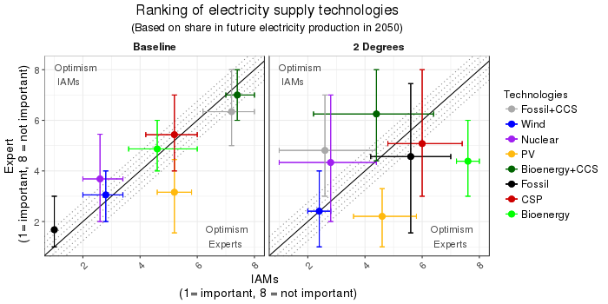
Figure 1 – mean ranking of energy technologies in the energy system in 2050 for both the experts and IAMs. The range provided represents the 15th and 85th percentile of total outcomes. Diagonal line indicates consensus whereas the shaded area represents a range of max 1-point differences.

Individual Technologies projections and evaluation
In two subsequent steps, we asked the expert groups to provide quantitative estimates for their short (2030) to medium (2050) term projections for the metrics in Table 3. In Figure 2 we depict the range of outcomes for the Baseline scenario and Figure 3 for the 2 Degrees scenario. For comparison purposes we portray elicited results together with IAM outcomes. In a subsequent step the experts have been confronted with the IAM results and have been asked to qualitatively evaluate the values from “too low” to “too high” with three intermediate steps. The mean values of these assessments are also presented in Figure 2 and Figure 3.

Under Baseline considerations (see Figure 2) the main systemic differences between experts and IAMs are found in the misrepresentation of short-term trends: The experts reported short-term values for installed capacity that are mostly higher than those projected by IAMs, with nuclear as an exception. This is particularly true for solar PV, showing substantially higher estimates by experts than IAMs, which can partly be attributed to the lack of representation of recent rapid growth in solar PV in IAMs (REN21, 2016). Moreover, the expert projections of nuclear depict an opposite trend to IAM projections, with experts being more conservative on the short-term given the expected retirement of existing capital in the coming decade (World Nuclear Association, 2016). Similar conclusions can be drawn from the share of nuclear in power production, reflecting a large uncertainty about short-term developments for nuclear though with the expectancy that nuclear shares are on the decline over a longer time horizon. This difference to IAMs may also be attributable to the earlier addressed deviating assumptions the economics of mitigation technology, leading to capital retirement and subsequent new construction for nuclear power in the near future.

The answers of the experts remained roughly consistent in depicting these systematic differences with IAMs when (1) considering the two system change metrics, (2) when moving out in the future to 2050, as well as in their (3) evaluation of the average values of IAMs for similar metrics.

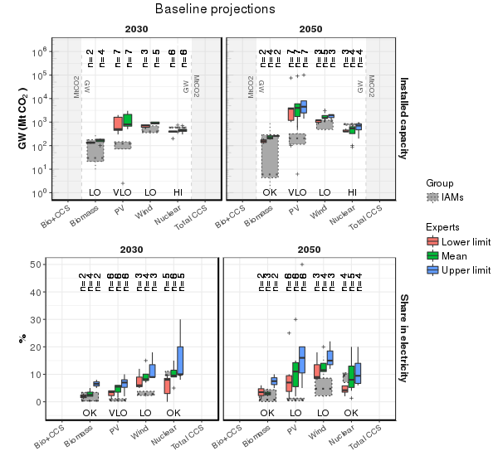
Figure 2 –Elicited indicators under Baseline assumptions by each technology specific expert group. Grey boxes represent IAM outcomes, the mean value is presented by a dotted line. The numbers in top parenthesis represent the number of actual elicitations per technology. The labels on the bottom indicate the average rating of the expert evaluation of average IAM projections: VLO: Very Low, LO: Low, OK: Reasonable, HI: High, VHI: Very High. In some occasions the expert provided only a mean value, whereas in other cases only a range (min and max) has been estimated.
Under 2 Degrees considerations (see Figure 3) we find three main observations which appear to be independent of the considered time period:

- Higher expert projections: The range of estimations for wind and PV remain structurally higher for experts than considered by IAMs, although the values are slightly converging over time. This difference may partly be attributed to the presumed availability of CCS and bioenergy (creating negative emissions) by IAMs, which lead to more conservative images for renewable energy technologies over the short term (Kriegler et al., 2014). In that sense, the cost-optimality paradigms devised by IAMs depict an overall different decarbonization narrative than the experts assuming no or limited availability of negative emission technologies in power supply (as can be deducted from figure 1).

- Illusion of agreement: Alternatively, technologies that depict an overlap in estimated values of experts and IAMs may falsely reflect agreement. This is particularly the case for bioelectricity, as experts articulated that biomass co-firing can be very effective as it can be installed relatively quickly and retrofitted into existing capital. However, the experts stressed simultaneously that additional incentives are necessary to move biomass into power generation and away from other utilizations, which they seemed less likely to happen for larger scales of application. Interestingly, as described in (Calving et al., 2013), scrutinizing a similar ensemble of models as this study, IAMs depict a similar rationale by dedicating a larger share of biomass resources to liquid fuel production (and not electricity). This difference of scale thus underlines a disagreement on the availability and economics of mitigation alternatives in the liquids and electricity production sectors between experts and IAMs. Similar for nuclear, although the quantitative estimates seem aligned, the experts articulated a more sceptical view on the future role of nuclear energy in a global power system than included in IAM projections. This difference may be a result of the various complications that enshrine nuclear energy (e.g. energy, environment and security considerations) which are considered by experts, but not entirely accounted for by IAMs.

- Higher IAM projections: A clear discrepancy comes to light for the considered CO₂ capture capacities, showing higher values for IAM projections than for expert projections. Moreover, the experts show to be more divided in their quantitative projections for CO₂ capture capacities, as reflected in the wide spread of expert estimates in Figure 3 for CCS technologies, but particularly for BECCS. Interestingly, the IAMs depict more-or-less harmonious values on the needed level of mitigation per year.

Similar to the Baseline outcomes, the experts remained broadly consistent in their answers throughout the direct and indirect elicitation methods. However, we find that under 2 Degrees considerations the experts appears to add more weight to their evaluation of average IAM outcomes, hinting at the presence of some threshold in acceptable rate of change such as observed for biomass.

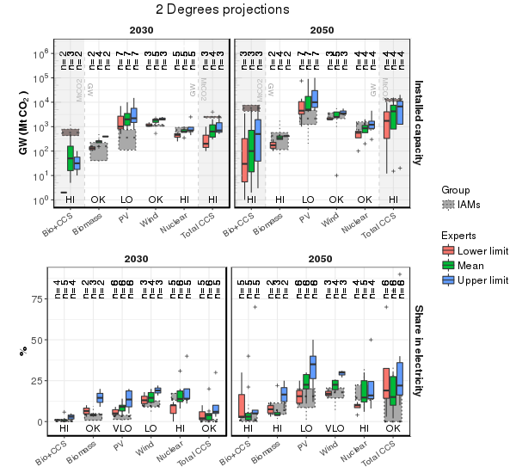
Figure 3 - Elicited indicators under 2 Degrees assumptions by each technology specific expert group. Grey boxes represent IAM outcomes. The numbers in top parenthesis represent the number of actual elicitations per technology. The labels on the bottom indicate the average rating of the expert evaluation of average IAM projections: VLO: Very Low, LO: Low, OK: Reasonable, HI: High, VHI: Very High. In some occasions the expert provided only a mean value, whereas in other cases only a range (min and max) has been estimated. The mean value of the IAMs is presented by a dotted line.

Discussion
In this study, we have compared the future outlooks of experts to the projections of IAMs. The results exposed some consensus between the IAM outcomes and expert judgements among future technology deployment levels over time. At the same time, also diverging views have come to light – especially for stringent mitigation scenarios. This disagreement can be found between the two knowledge sources, but also within experts representing each of the two sources. In the following paragraphs we briefly discuss the possible underlying factors contributing to the observed differences.

Limitations by design: IAMs
Integrated assessment models are instruments specifically used to test the implications of specific policies or uncertainties over time in a consistent and structured framework. This study has used projections developed in the 2011-2014 period to explore idealised best-case scenarios with immediate global action. Experts might have had in mind several factors that would lead reality unfolding away from these idealised path. Clearly, these optimal conditions do not exist in the real world, but are intended to provide policy-makers with a reference compared to in-action. As described in Eom et al. (2015); Riahi et al. (2015), IAM scenarios that include more suboptimal conditions (e.g. delays in global action and limited availability of key technologies for large scale application), would yield a broader set of responses as well.

Secondly, in their representation of energy systems, IAMs are inherently dependent on available contemporary knowledge of aggregated techno-economic trends and causalities. By adopting also necessary simplifications, IAMs are inherently compromising their (1) system representativeness (e.g. do the models include all technologies?) as well as their (2) reflection of current trends and grassroots developments. In some cases, one might argue that this means that models do not accommodate the breadth of expert knowledge. Indeed, experts articulated specific roles for technologies and policy measures that models typically do not reproduce, such as decentralised power systems, geothermal electricity or lifestyle change. This caveat in models is a result of technology uncertainty and/or the inability to translate a technology choice into a representative cost-benefit formulation in models. The lack of such explicit detail in IAMs on, amongst others, the scalability and potential for decentralised applications of solar of wind resources, thus creates some bias towards the more large-scale, centralised, technologies.

Finally, the complexity of the models also leads to inertia. This can be problematic for short-term projections as information on technologies under rapid development can be quickly outdated. Although the work presented to the experts can be considered of relatively recent nature (which had been published simultaneously in IPCC WGIII CH6 in 2014), in most cases these models were not calibrated to newer sources than published prior to 2010. Earlier studies exposed such conservatism in long-term scenario logic as well as in the assumptions on the driving forces (Metayer et al., 2015; Vuuren and O'Neill, 2006), which underline that modellers need to continuously update their models to create more representative projections for the short-term. However, although more short-term accuracy may lead to some changes to the depicted mitigation strategies of IAMs, it is important to note that it does not affect the more long-term patterns, such as found for the decarbonization of sectors and systems.

Limitations by design: experts
The results of the experts in this study may be prone to various cognitive biases and contingent on the type of experts involved. Given the uncertain character of future developments as well as mobilizing the experts’ tacit knowledge, the outcomes may not be reproduced by other experts and can therefore not be directly submitted to empirical control (Cooke, 1991). For example, the projections of IAMs are bounded by global greenhouse gas budgets and imposed climate targets, but it remains unknown whether the experts' estimates are aligned with available emission budgets to meeting the 2˚C climate target or whether alternative realities are considered.

In this study, we also compared various technologies of which some are proven technologies and others are emerging new technologies, which could have influenced the outcomes. Nuclear energy, for example, is a more mature technology compared to renewable energy technologies, having experienced large scale commercialization since the 1960s and is characterized by both strong support and strong criticism ‘camps’ (Bruggink and van der Zwaan, 2002). The conservative outcomes of the nuclear elicitation group may hint towards an overrepresentation of the latter – though similar conservative conclusions have been drawn in other elicitations on the future competitiveness of nuclear energy (Anadón et al., 2012). Alternatively, unprecedented growth per subsequent year, as found in carbon-free technologies, may reinforce experts to provide a high estimate on future growth. In particular wind (showing a higher annual growth rate than the cumulative sustained growth over the last decade, see Global Wind Energy Council (2015)) and PV (IRENA, 2016) might be liable to such optimism bias. Alternatively, the wake of the successful COP21 could have also led to reinforced optimism (or uncertainty) to articulate unprecedented rates of change.

Conclusion
In this study, we confronted the outcomes of IAMs to the estimates of experts to provide insights on deployment trends and compared them to projections by IAMs. We have included answers of 39 experts divided over 5 technology families under two different climate policy scenarios for the near (2030) and medium (2050) term. Subsequently we asked the participating experts to assess the levels as projected by IAMs under similar climate considerations and timeframes.

Experts and IAMs show consensus on power system developments over time under Baseline considerations, although some structural differences exist in terms of scales and speeds.
The study exposed some consensus among the scrutinized knowledge sources on the direction of status-quo system change over time. Overall the general view of either knowledge source considers the continued use of fossil fuel resources with some contribution of renewable sources. A difference between IAMs and experts is found in the depicted scales and speeds of change, which might be influenced by not having represented recent trends in IAMs, lack of detail for technologies on a more distributed or decentralized basis and latency for model improvements to become available. This is reflected by the expert groups being notably more optimistic about the growth of intermittent power technologies than given by the models, especially for PV.

Under stringent climate policy, model projections and experts evaluations start to diverge within and between the experts and IAMs.
More diverging views come to light when more stringent climate policy is assumed, both within and among IAMs and experts. Some overlap can be observed between the IAM and expert projections, hinting at agreement, however, experts have expressed restraint for some depicted values, in particular for biomass in power production as well as nuclear and CCS. Although it can be partly attributed to different expectations in the availability and economics of mitigation technologies, it also underlines that more complex dynamics need to be taken into consideration to represent plausible future pathways than currently accounted for in IAMs.

Expert elicitation may provide useful feedback to IAMs on generating more representative mitigation strategies
The levels of deployment and scalability of technologies as provided by IAMs in this study are a reflection of the included technological portfolio and responsiveness to (carbon) pricing policies. In some cases this proved to be insufficient to (1) accommodate the breadth of expert knowledge and (2) depict rates of change that are more aligned to (expert) expectancies. The experts highlighted in particular an area of misrepresented technological potential for renewable energy technologies, as IAMs tend to offset the growth of renewable energy technologies by implementing more large scale, centralised, technologies (such as bioelectricity and CCS). Future research could address these differences in future outlooks by including greater detail in IAMs, as well as considering more context-inclusive pathways as opposed to optimal pathways to gain better insights on plausible future pathways.

The elicited metrics allow for a broader discussion on achievable and likely energy system change
The elicited metrics showed that not one single metric may provide conclusive insights on both (1) achievable and (2) likely technological change over time. Hence, the interplay of quantitatively elicited metrics and their qualitative evaluation may be used to detect several market uncertainties and other non-linearities that are not clearly represented in IAMs. Given how the considered metrics are output parameters to most IAMs, it allows for a broader rather than a model-specific discussion on modelling performance and long-term scenario logic.

Acknowledgements
The research leading to these results has received funding from the European Union Seventh Framework Programme FP7/2007-2013 under grant agreement n° 282846 (LIMITS) and n° 603942 (PATHWAYS). BvdZ also acknowledges the financial assistance from the EU TRANSRISK project (Horizon 2020 research and innovation programme, grant agreement n° 642260). The authors are indebted to all contributing technology experts for partaking in this research. We would also like to thank Hilke Rösler for her research assistance.

References
Anadón, L.D., Bosetti, V., Bunn, M., Catenacci, M., Lee, A., 2012. Expert Judgments about RD&D and the Future of Nuclear Energy. Environmental Science & Technology 46, 11497-11504.
Anderson, K., 2015. Duality in climate science. Nature Geosci 8, 898-900.
Baker, E., Bosetti, V., Jenni, K.E., Ricci, E.C., 2014. Facing the Experts: Survey Mode and Expert Elicitation. FEEM Working Paper No. 1.2014. Available at SSRN: https://ssrn.com/abstract=2384487 or http://dx.doi.org/10.2139/ssrn.2384487
Baker, E., Chon, H., Keisler, J., 2009. Carbon capture and storage: combining economic analysis with expert elicitations to inform climate policy. Climatic Change 96, 379-408.
Baker, E., Chon, H., Keisler, J.M., 2008. Advanced Nuclear Power: Combining Economic Analysis with Expert Elicitations to Inform Climate Policy.
Bauer, N., Mouratiadou, I., Luderer, G., Baumstark, L., Brecha, R.J., Edenhofer, O., Kriegler, E., 2013. Global fossil energy markets and climate change mitigation – an analysis with REMIND. Climatic Change, 1-14.
Bosetti, V., Anadón, L.D., Baker, E., Reis, L.A., Verdolini, E., 2016. The Future of Energy Technologies: An Overview of Expert Elicitations. GGKP Research Committee on Technology and Innovation Working Paper 01 2016.
Bosetti, V., Carraro, C., Galeotti, M., Massetti, E., Tavoni, M., 2006. WITCH: A World Induced Technical Change Hybrid Model. The Energy Journal.
Bosetti, V., Catenacci, M., Fiorese, G., Verdolini, E., 2012. The future prospect of PV and CSP solar technologies: An expert elicitation survey. Energy Policy 49, 308-317.
Bruggink, J.J.C., van der Zwaan, B.C.C., 2002. The role of nuclear energy in establishing sustainable energy paths. International Journal of Global Energy Issues 18, 151-180.
Calvin, K., Clarke, L., Krey, V., Blanford, G., Jiang, K., Kainuma, M., Kriegler, E., Luderer, G., Shukla, P.R., 2012. The role of Asia in mitigating climate change: Results from the Asia modeling exercise. Energy Economics 34, Supplement 3, S251-S260.
CALVIN, K., WISE, M., KLEIN, D., McCOLLUM, D., TAVONI, M., VAN DER ZWAAN, B., VAN VUUREN, D.P., 2013. A MULTI-MODEL ANALYSIS OF THE REGIONAL AND SECTORAL ROLES OF BIOENERGY IN NEAR- AND LONG-TERM CO2 EMISSIONS REDUCTION. Climate Change Economics 04, 1340014.
Chan, G., Anadon, L.D., Chan, M., Lee, A., 2011. Expert elicitation of cost, performance, and RD&amp;D budgets for coal power with CCS. Energy Procedia 4, 2685-2692.
Clarke, L., Jiang, K., Akimoto, K., Babiker, M., Blanford, G., Fisher-Vanden, K., Hourcade, J.-C., Krey, V., Kriegler, E., Löschel, A., McCollum, D., Paltsev, S., Rose, S., Shukla, P.R., Tavoni, M., van der Zwaan, B.C.C., van Vuuren, D.P., 2014. Assessing Transformation Pathways. In: Climate Change 2014: Mitigation of Climate Change. Contribution of Working Group III to the Fifth Assessment Report of the Intergovernmental Panel on Climate Change. [Edenhofer, O., R. Pichs-Madruga, Y. Sokona, E. Farahani, S. Kadner, K. Seyboth, A. Adler, I. Baum, S. Brunner, P. Eickemeier, B. Kriemann, J. Savolainen, S.Schlömer, C. von Stechow, T. Zwickel and J.C. Minx (eds.)]. Cambridge University Press, Cambridge, United Kingdom and New York, NY, USA.
Cooke, R., 1991. Experts in Uncertainty : Opinion and Subjective Probability in Science. Oxford University Press, New York.
Curtright, A.E., Morgan, M.G., Keith, D.W., 2008. Expert Assessments of Future Photovoltaic Technologies. Environmental Science & Technology 42, 9031-9038.
Edenhofer, O., Pichs-Madruga, R., Sokona, Y., Seyboth, K., Matschoss, P., Kadner, S., Zwickel, T., Eickemeier, P., Hansen, G., Schlömer, S., von Stechow, C., 2011. IPCC Special Report on Renewable Energy Sources and Climate Change Mitigation. Cambridge University Press, United Kingdom and New York, NY, USA.
Eom, J., Edmonds, J., Krey, V., Johnson, N., Longden, T., Luderer, G., Riahi, K., Van Vuuren, D.P., 2015. The impact of near-term climate policy choices on technology and emission transition pathways. Technological Forecasting and Social Change 90, Part A, 73-88.
European Commission, 2011. Communication from the commission to the European Parliament, the Council, the European Economic and Social Committee and the Committee of the Regions. A Roadmap for moving to a competitive low carbon economy in 2050.
European Union, 2012. Energy roadmap 2050 (COM(2011) 885 final of 15 December 2011).
Fiorese, G., Catenacci, M., Bosetti, V., Verdolini, E., 2014. The power of biomass: Experts disclose the potential for success of bioenergy technologies. Energy Policy 65, 94-114.
GEA, 2012. Global Energy Assessment - Toward a Sustainable Future, Cambridge University Press, Cambridge, UK and New York, NY, USA and the International Institute for Applied Systems Analysis, Laxenburg, Austria.
Global Wind Energy Council, 2015. Global status of wind power in 2015.
IRENA, 2016. Letting in the light - how solar photovoltaics will revolutionise the electricity system.
Keeney, R.L., von Winterfeldt, D., 1991. Eliciting probabilities from experts in complex technical problems. IEEE Transactions on Engineering Management 38, 191-201.
Keppo, I., Zwaan, B., 2011. The Impact of Uncertainty in Climate Targets and CO2 Storage Availability on Long-Term Emissions Abatement. Environmental Modeling & Assessment 17, 177-191.
Kramer, G.J., Haigh, M., 2009. No quick switch to low-carbon energy. Nature 462, 568-569.
Kriegler, E., Petermann, N., Krey, V., Schwanitz, V.J., Luderer, G., Ashina, S., Bosetti, V., Eom, J., Kitous, A., Méjean, A., Paroussos, L., Sano, F., Turton, H., Wilson, C., Van Vuuren, D.P., 2015a. Diagnostic indicators for integrated assessment models of climate policy. Technological Forecasting and Social Change 90, Part A, 45-61.
Kriegler, E., Riahi, K., Bosetti, V., Capros, P., Petermann, N., van Vuuren, D.P., Weyant, J.P., Edenhofer, O., 2015b. Introduction to the AMPERE model intercomparison studies on the economics of climate stabilization. Technological Forecasting and Social Change 90, Part A, 1-7.
Kriegler, E., Tavoni, M., Aboumahboub, T., Luderer, G., Calvin, K.V., Demaere, G., Krey, V., Riahi, K., Rösler, H., Schaeffer, M., van Vuuren, D.P., 2013. What does the 2°C target imply for a global climate agreement in 2020? The LIMITS study on Durban platform scenarios. Climate Change Economics 04, 1340008.
Kriegler, E., Weyant, J.P., Blanford, G.J., Krey, V., Clarke, L., Edmonds, J., Fawcett, A., Luderer, G., Riahi, K., Richels, R., Rose, S.K., Tavoni, M., van Vuuren, D.P., 2014. The role of technology for achieving climate policy objectives: overview of the EMF 27 study on global technology and climate policy strategies. Climatic Change 123, 353-367.
Luderer, G., Leimbach, M., Bauer, N., Kriegler, E., 2013. Description of the REMIND model (Version 1.5).
Marquard, J.L., Robinson, S.M., 2008. Reducing Perceptual and Cognitive Challenges in Making Decisions with Models, In: Kugler, T., Smith, J.C., Connolly, T., Son, Y.-J. (Eds.), Decision Modeling and Behavior in Complex and Uncertain Environments. Springer New York, New York, NY, pp. 33-55.
Martin, T.G., Burgman, M.A., Fidler, F., Kuhnert, P.M., Low-Choy, S., McBride, M., Mengersen, K., 2012. Eliciting Expert Knowledge in Conservation Science
Obtención de Conocimiento de Expertos en Ciencia de la Conservación. Conservation Biology 26, 29-38.
Messner, S., Strubegger, M., 1995. User’s guide for MESSAGE III. International Institute for Applied Systems Analysis (IIASA).
Metayer, M., Breyer, C., Fell, H.J., 2015. The projections for the future and quality in the past of the World Energy Outlook for solar PV and other renewable energy technologies, Energy Watch Group.
Morgan, M.G., 2014. Use (and abuse) of expert elicitation in support of decision making for public policy. Proceedings of the National Academy of Sciences 111, 7176-7184.
Napp, T., Gambhir, A., Thomas, R., Hawkes, A., Bernie, D., Lowe, J., 2015. Exploring the feasibility of low-carbon scenarios using historical energy transitions analysis.
Nemet, G.F., Baker, E., Jenni, K.E., 2013. Modeling the future costs of carbon capture using experts' elicited probabilities under policy scenarios. Energy 56, 218-228.
Rao, A.B., Rubin, E.S., Keith, D.W., Granger Morgan, M., 2006. Evaluation of potential cost reductions from improved amine-based CO2 capture systems. Energy Policy 34, 3765-3772.
REN21, 2014. Global Status Report.
REN21, 2016. Global Status Report.
Riahi, K., Kriegler, E., Johnson, N., Bertram, C., den Elzen, M., Eom, J., Schaeffer, M., Edmonds, J., Isaac, M., Krey, V., Longden, T., Luderer, G., Méjean, A., McCollum, D.L., Mima, S., Turton, H., van Vuuren, D.P., Wada, K., Bosetti, V., Capros, P., Criqui, P., Hamdi-Cherif, M., Kainuma, M., Edenhofer, O., 2015. Locked into Copenhagen pledges — Implications of short-term emission targets for the cost and feasibility of long-term climate goals. Technological Forecasting and Social Change 90, Part A, 8-23.
Schwanitz, V.J., 2013. Evaluating integrated assessment models of global climate change. Environmental Modelling & Software 50, 120-131.
Sims, R.E.H., Schock, R.N., Adegbululgbe, A., Fenhann, J., Konstantinaviciute, I., Moomaw, W., Nimir, H.B., Schlamadinger, B., 2007. Chapter 4: Energy Supply, Internation panel of climate change.
Stehfest, E., van Vuuren, D.P., Kram, T., Bouwman, L., Alkemade, R., Bakkenes, M., Biemans, H., Bouwman, A., den Elzen, M., Janse, J., Lucas, P.L., van Minnen, J., Muller, M., Prins, A.G., 2014. policy applications Integrated Assessment of Global Environmental Change with IMAGE 3.0 - Model description and policy applications.
Stern, N., 2016. Economics: Current climate models are grossly misleading, Nature, pp. 407–409.
Tavoni, M., Kriegler, E., Riahi, K., van Vuuren, D.P., Aboumahboub, T., Bowen, A., Calvin, K., Campiglio, E., Kober, T., Jewell, J., Luderer, G., Marangoni, G., McCollum, D., van Sluisveld, M., Zimmer, A., van der Zwaan, B., 2015. Post-2020 climate agreements in the major economies assessed in the light of global models. Nature Clim. Change 5, 119-126.
Van Der Zwaan, B.C.C., Rösler, H., Kober, T., Aboumahboub, T., Calvin, K.V., Gernaat, D.E.H.J., Marangoni, G., McCollum, D., 2013. A cross-model comparison of global long-term technology diffusion under a 2°C climate change control target. Climate Change Economics 04, 1340013.
van Sluisveld, M.A.E., Harmsen, J.H.M., Bauer, N., McCollum, D.L., Riahi, K., Tavoni, M., Vuuren, D.P.v., Wilson, C., Zwaan, B.v.d., 2015. Comparing future patterns of energy system change in 2 °C scenarios with historically observed rates of change. Global Environmental Change 35, 436-449.
van Vuuren, D.P., Edmonds, J., Smith, S.J., Calvin, K.V., Karas, J., Kainuma, M., Nakicenovic, N., Riahi, K., van Ruijven, B.J., Swart, R., Thomson, A., 2010. What do near-term observations tell us about long-term developments in greenhouse gas emissions? Climatic Change 103, 635-642.
Vaughan, N.E., Gough, C., 2016. Expert assessment concludes negative emissions scenarios may not deliver. Environmental Research Letters 11, 095003.
Vuuren, D.P., O'Neill, B.C., 2006. The Consistency of IPCC's SRES Scenarios to 1990–2000 Trends and Recent Projections. Climatic Change 75, 9-46.
Weyant, J., Kriegler, E., 2014. Preface and introduction to EMF 27. Climatic Change 123, 345-352.
Wilson, C., Grubler, A., Bauer, N., Krey, V., Riahi, K., 2012. Future capacity growth of energy technologies: are scenarios consistent with historical evidence? Climatic Change 118, 381-395.
World Nuclear Association, 2016. Plans For New Reactors Worldwide. World Nuclear Association.

Supplementary Material

Participants and affiliations
Name | Contact | Group
Berndes, Goran | goran.berndes@chalmers.se | Biomass
Haara, Karin | karin.haara@worldbioenergy.org | Biomass
Junginger, Martin | h.m.junginger@uu.nl | Biomass
Smith, Pete | pete.smith@abdn.ac.uk | Biomass
Fritsche, Uwe | uf@iinas.org | Biomass
Slade, Raphael | r.slade@imperial.ac.uk | Biomass
Wellinger, Arthur | wellinger@triple-e-und-m.ch | Biomass
Dehue, Bart | bart.dehue@nuon.com | Biomass
Rauner, Sebastian | sebastian.rauner@ufz.de | Biomass
Chum, Helena | Helena.Chum@nrel.gov | Biomass
Saygin, Deger | DSaygin@irena.org | Biomass
Haara, Karin | karin.haara@worldbioenergy.org | Biomass
Ramana, M.V. | ramana@princeton.edu | Nuclear
H. Kim, Son | skim@pnnl.gov | Nuclear
Rogner, Holger | rogner@iiasa.ac.at | Nuclear
Gritsevskyi, Andrii | A.Gritsevskyi@iaea.org | Nuclear
Katsuta, Tadahiro | tkatsuta@kisc.meiji.ac.jp | Nuclear
Bunn, Matthew | matthew_bunn@harvard.edu | Nuclear
Lenardic, Denis | contact@pvresources.com | PV
Jager-Waldau, Arnulf | arnulf.jaeger-waldau@ec.europa.eu | PV
van Sark, Wilfried | W.G.J.H.M.vanSark@uu.nl | PV
Rekinger, Manoel | m.rekinger@epia.org | PV
Philipps, Simon | simon.philipps@ise.fraunhofer.de | PV
Mayer, Johannes | johannes.nikolaus.mayer@ise.fraunhofer.de | PV
Arvizu, Dan | dan_arvizu@nrel.gov | PV
Wiser, Ryan | RHWiser@lbl.gov | Wind
de Jager, David | d.dejager@ecofys.com | Wind
Infield, David | david.infield@eee.strath.ac.uk | Wind
Sinden, Graham | graham.sinden@trinity.oxon.org | Wind
Shukla, Shruti | shruti.shukla@gwec.net | Wind
Jensen, Peter | peter.hjuler@risoe.dk | Wind
Sawyer, Steve | steve.sawyer@gwec.net | Wind
Abanades, Juan Carlos | abanades@incar.csic.es | CCS
Van den Brink, Ruud | vandenbrink@ecn.nl | CCS
Berghout, Niels | N.A.Berghout@uu.nl | CCS
Ramirez Ramirez, Andrea | C.A.Ramirez@uu.nl | CCS
Kuramochi, Takeshi | t.kuramochi@newclimate.org | CCS
Lupion, Monica | m.lupion@ciuden.es | CCS
Herber, Rien | rien.herber@rug.nl | CCS

Survey questions

Training for “quantitative expert projections”
Throughout the survey, we will make use of two possible global scenarios: one without additional global climate policy (A) and one with a stringent global climate policy (B):

Scenario | Description
A | A "no climate policy" baseline ('business as usual'). In this scenario, we assume there will be no new global agreement on international climate policy. The energy system will therefore mostly be driven by factors other than climate policy.
B | Stringent and immediate global climate policy. We assume that stringent climate policies are introduced worldwide in the short term in order to achieve a 50% reduction in global emissions by 2050, with the aim of restricting climate change to a maximum of 2 degrees Celsius.

Snapshot of self-assessment/ranking questions (example shown for only scenario A)
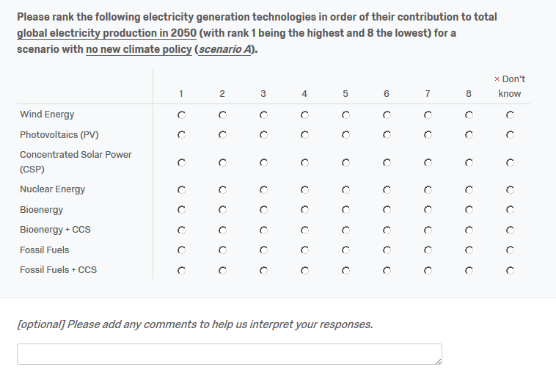
Snapshot of quantitative projection question (PV as example, total installed capacity)
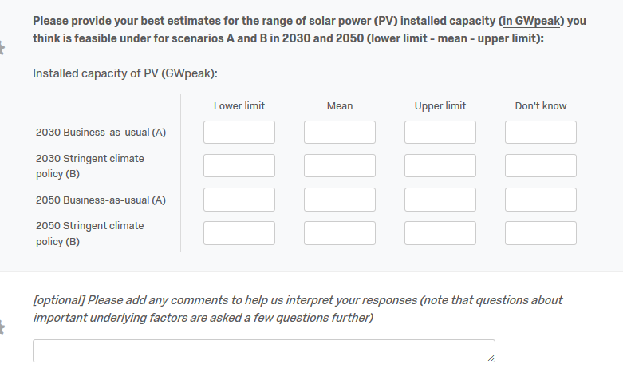

Training for “qualitative evaluation of IAM projections”
In LIMITS, we have used global energy-environment models to explore the two scenarios introduced earlier , with different assumptions on global climate policy (see above for a description of the scenarios). The results of the different models vary greatly and the values shown are the means *. We would like you to assess the outcomes of this project. Here, we look at the installed capacity of PV installations on a global scale. For guidance purposes we have provided a recent historical reference point (EPIA, value in 2013).

* The depicted projection is the average of 7 global energy-environment models in the LIMITS project. If you would like to know more about the model assumptions, we would be happy to send you articles on the outcomes of the LIMITS scenarios.
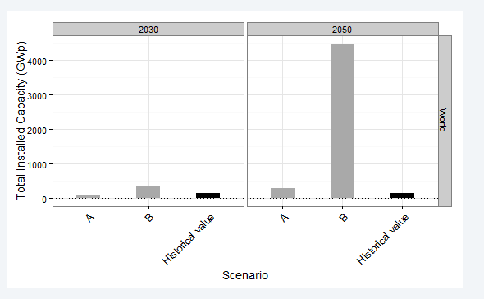

Snapshot of qualitative evaluation question (PV example, total installed capacity)
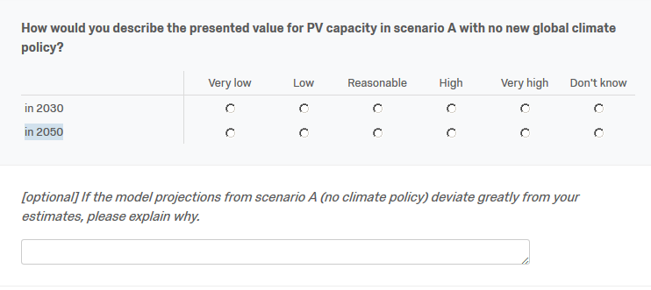

Ranking of experts (group versus total)

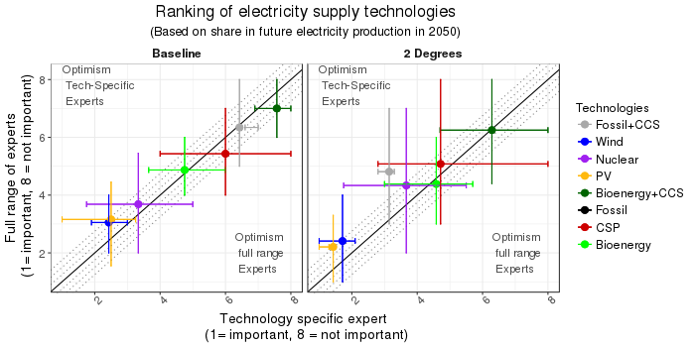
Figure 4 - mean ranking of energy technologies in the energy system in 2050 for both specific technology groups versus the total number of experts. The range provided represents the 15th and 85th percentile of total outcomes. Diagonal line indicates consensus whereas the shaded area represents a range of max 1-point differences.

During the design of the elicitation protocol the IPCC AR5 WGIII report was not yet published.

